Chapter 13, Solution 63.

Find the mesh currents in the circuit of Fig. 13.128 below.

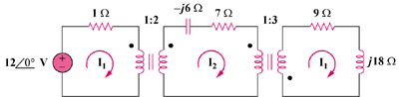

Figure 13.128
For Prob. 13.63.

Solution

Reflecting the (9 + j18)-ohm load to the middle circuit gives,

Z_{in}’ = 7 – j6 + (9 + j18)/(n’)² = 7 – j6 + 1 + j2 = 8 – j4 when n’ = 3

Reflecting this to the primary side,

Z_{in} = 1 + Z_{in}’/n² = 1 + 2 – j = 3 – j, where n = 2

I₁ = 12∠0°/(3 – j) = 12/3.162∠–18.43° = 3.795∠18.43° A

I₂ = I₁/n = 1.8975∠18.43° A

I₃ = –I₂/n² = 632.5∠161.57° mA

